2026 Vendor Sponsors
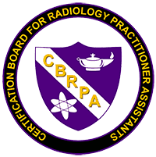

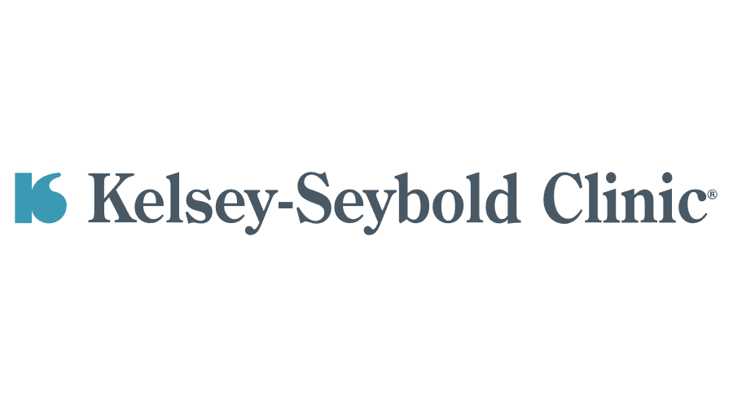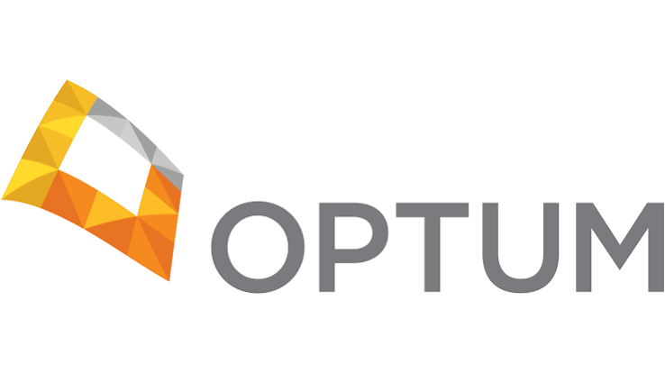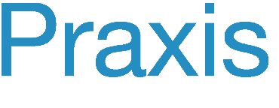



Thank you for your support
ARPE 2026 Syllabus
Eighteenth Annual ARPE Educational Symposium
ARPE Sep 29-Oct 1 2026 Schedule
20 HRS of A+ CE and ACLS (6hrs)*

Tuesday Sep 29
07:30-8:00 am On-site Registration and Check in
Opening Remarks

08:00- 09:00am (1) The RRA role and scope of practice updates

09:00-10:00am (1) Apheresis Cather Update on Types and Results, Sean Wiley RRA/RPA, University of Florida

10:00-11:00am (1) Thoracic Radiology, Dr. Jewel Appleton, Kelsey Seybold

11:00am-12:00pm (1) Thinking Like a Radiologist: Developing a Diagnostic Mindset, Dr. Peter Geertruyden, Medical Center Radiologists, Inc.

12:00-2:00pm Lunch on your Own

2:00-3:00pm (1) Pediatric Venous Catheters Sean Wiley RRA/RPA, University of Florida

3:00-4:00pm (1) IR Unknown Cases Sean Wiley RRA/RPA, University of Florida

4:00-5:00pm (1) Pediatric Radiology Pt.1, Steve Kraus, MD, University of Kentucky College of Medicine

5:00-6:00pm (1) Genitourinary Imaging of the Female Pelvis, Dr. Jewel Appleton, Kelsey Seybold

7:00-10:00pm Social
(8 hrs total CME)

Wednesday Sept 30
8:00-9:00 am (1) Tips and Tricks in IR, Sean Wiley RRA/RPA, University of Florida

9:00-10:00am (1) Early Career Lessons: Cases That Changed How I Practice, Dr. Austin McCullough, Texas Children’s Hospital

10:00-11:00am (1) Pediatric Radiology Pt.2, Steve Kraus, MD, University of Kentucky College of Medicine

11:00am-12:00pm (1) Is Fluoroscopy Still Relevant in the Current Imaging World? Travis Prowant RRA, VCU Health System

12:00-2:00pm Lunch on your own

2:00-3:00pm (1) Structural Heart Disease in Adults, Neil Holtz, EMT-P, Emory
University Hospital

3:00-4:00pm (1) Every Scan Tells a Story; What Whole Body MRI Reveals Before Symptoms Begin, Dr. Todd Berry, Prenuvo LLC

4:00-5:00pm (1) Who Really Decides? Understanding the Business Behind Your Radiology Department and Hospital System, Stan Schroeder, Managing Partner, Veri-Sage Advisors

6:00-8:00pm Vendor Social
(7 hrs Total CME)

Thursday Oct 1
8:00-9:00am (1) ARRT RRA Practicum Review, Danielle Martin, RRA/RPA,
Radiology Associates of North Texas and Melissa Cano, RPA, Texas Children’s Hospital

9:00-10:00am (1) Pediatric Interesting Cases: A to Z, Dr. Austin McCullough, Texas
Children’s Hospital

10:00-11:00am (1) ACS and localizing STEMI and Non-STEMI on the ECG, Neil Holtz, EMT-P, Emory University Hospital

11:00-12:00pm (1) When the Supply Chain Reaches the Bedside, Stan Schroeder, Managing Partner, Veri-Sage Advisors

12:00-1:00pm (1) New Clinical Studies and Procedures Provided by Interventional Radiology, Sean Wiley RRA/RPA, University of Florida
(5 hrs Total CME)

Thursday Oct 1
1:00-3:00pm ACLS with Neil Holtz, EMT-P, Emory University Hospital
*counts as 6hr CE for ARRT renewal

Alternate Talks: Pediatric Venous Catheters by Sean Wiley and IR Unknown cases by Sean Wiley

Tuesday September 29
The RRA role and scope of practice updates
Role and core responsibilities
Scope of practice and limitations
MARCA bill and changes
The future of the RRA and RPA

Apheresis Cather Update on Types and Results, Sean Wiley RRA/RPA, University of Florida

- Types of Apheresis catheters
  - Staggered tip
  - End hole
  - Temporary vs. Tunneled
  - Ports

- Machine operation

- Flow rates

- Catheter recirculation and time

- Report of Multi-center evaluation
  - Catheter type
  - Flow rates
  - Recirculation

- Catheter radiographic evaluation

- How ports work for Apheresis
  - Patient population
  - Disease process
  - Indication/Risk

Thoracic Radiology, Dr. Jewel Appleton, Kelsey Seybold

Multimodality Thoracic anatomy to include chest xray, CT and MRI
Case based review of various emergent and routine diagnoses

Thinking Like a Radiologist: Developing a Diagnostic Mindset, Dr. Peter Geertruyden, Medical Center Radiologists, Inc.

Learning Objectives
At the conclusion of this presentation, participants will be able to:
- Apply a systematic radiologist-style approach to image interpretation and image-guided procedures.
- Recognize clinically significant incidental findings encountered during routine imaging examinations and fluoroscopic or ultrasound-guided procedures.
- Identify common cognitive biases and technical pitfalls that contribute to diagnostic and procedural errors.
- Incorporate practical pearls that improve safety, communication, and procedural success during image-guided interventions.

Outline

I. Thinking Like a Radiologist
- Thinking beyond the indication
- Systematic search patterns
- Avoiding cognitive bias
- Looking outside the area of interest

II. Cases That Changed Management
Examples:
- Lung mass on a barium swallow scout image
- Unexpected aspiration
- Incidental thyroid mass
- Bone lesion seen during shoulder imaging
- Occult fracture before planned injection
- Infection discovered before a routine procedure
Teaching point:
"Always ask yourself, 'What else am I seeing?'"

III. MSK Procedure Pearls and Pitfalls
This section could be 10–15 minutes and would probably be one of the audience's favorites.
Topics could include:

Before the needle
- Review prior imaging before entering the room.
- Confirm that the requested procedure matches the pathology.
- Make sure the imaging explains the patient's symptoms.
- Recognize contraindications (infection, fracture, unexpected aggressive lesion).

During the procedure
- Optimize patient positioning.
- Needle visualization tips.
- Contrast confirmation pearls.
- Avoiding common technical mistakes.
- Knowing when to reposition versus redirect.

After the procedure
- Recognize complications early.
- Documentation pearls.
- Patient instructions that reduce callbacks.
- When to obtain additional imaging.

Cases
For example:
"I was scheduled to inject a shoulder..."
...but the radiographs showed an unsuspected lytic lesion.
or
"Patient referred for hip injection..."
...MRI showed subchondral insufficiency fracture.
No injection.
Diagnosis changed.

IV. Communication
- When to stop the procedure
- When to involve the radiologist
- Communicating unexpected findings
- Closing the loop with referring providers

V. Take-Home Habits
The habits of great radiology extenders:
- Know the history.
- Review prior imaging.
- Look beyond the target.
- Think before you inject.
- Trust your instincts.
- Never ignore an incidental finding.
- Communicate early.

The Five Questions I Ask Before Every Procedure
- Is this the correct patient?
- Is this the correct procedure?
- Do the imaging findings explain the patient's symptoms?
- Is there anything unexpected that changes today's plan?
- If this were my family member, would I proceed?
Genitourinary Imaging of the Female Pelvis, Dr. Jewel Appleton, Kelsey Seybold
Pelvic Anatomy
Multimodality appearance of the Uterus and ovaries
Demonstrate the value of multimodality imaging in female pelvic imaging​
Case based overview on various diagnoses in female pelvic imaging​
Emergency topics in OB/GYN imaging
Pediatric Radiology Pt.1, Steve Kraus, MD, University of Kentucky College of Medicine
Cases that we encounter during our everyday practice teach us principles we will always remember.
During the presentations at this conference, you will be seeing a number of cases and we will go through the diagnostic imaging algorithm for a number of different pediatric indications that I hope will illustrate some teaching points to help you in your daily practice of pediatric radiology.
“Tell me and I forget.
Teach me and I remember.
Involve me and I learn”
-Benjamin Franklin
Wednesday September 30
Tips and Tricks in IR, Sean Wiley RRA/RPA, University of Florida
- Pediatric catheters TIPS and tricks
  - Placement
  - Catheter styles
  - Alternatives
- Feeding tube TIPS and Tricks
  - Placement techniques
  - Exchange techniques
- Tunneled catheter TIPS and Tricks
  - Placements
  - Removals
  - Exchanges
- Drainage catheter TIPS and Tricks
  - Placements
  - Securements
  - Removals

Early Career Lessons: Cases That Changed How I Practice, Dr. Austin McCullough, Texas Children’s Hospital

By the end of the lecture, participants should be able to:
- Recognize common challenges encounterd during the transition from trainee to practitioner.
- Develop practical strategies for approaching unfamiliar examinations, diagnostic uncertainty, and difficult clinical interactions.
- Identify habits that improve accuracy, promote lifeling learning, and reduce cognitive error.
- Appreciate the importance of communication, collaboration, and self-care in building a sustainable radiology career.
Brief Outline:
Each section will include a few cases that help demonstrate the principles of the lecture.
Transition: Learning on the fly, confidence vs humility, trusting your own judgement.
Communcation: Calling clinicians, learning from technologists, finding mentors.
Becoming Better: Avoiding bias, utilizing AI, leveraging resources
Sustainable practice: know your limits, managing fatigue, ergonomics, skill maintenance
Pediatric Radiology Pt.1, Steve Kraus, MD, University of Kentucky College of Medicine
Cases that we encounter during our everyday practice teach us principles we will always remember.
During the presentations at this conference, you will be seeing a number of cases and we will go through the diagnostic imaging algorithm for a number of different pediatric indications that I hope will illustrate some teaching points to help you in your daily practice of pediatric radiology.
“Tell me and I forget.
Teach me and I remember.
Involve me and I learn”
-Benjamin Franklin
Is Fluoroscopy Still Relevant in the Current Imaging World? Travis Prowant RRA, VCU Health System
Abstract:
This course will provide a broader understanding of the principles of fluoroscopy in radiology and a familiarity with the many diagnostic techniques available, their values and limitations, and how they may best be used in the management of the patient. With advancements in other imaging modalities such as CT and MR, many fluoroscopic examinations are no longer performed routinely. This course is designed to express the value of fluoroscopy, in both the dynamic nature whereby clinical questions can be answered, but also in the safety and cost-effectiveness realms.
Objectives:
By the end of this session the attendee will be able to:
- Explain how fluoroscopy is used to enhance overall patient care and department efficiency.
- Describe fluoroscopic operation to include the basic image production chain.
- Explain radiation protection strategies for the patient, radiographer and radiologist during fluoroscopic examination.
- Recite the patient preparation, various contrast materials used, basic patient positioning and patient education for gastrointestinal and genitourinary procedures.
- Discuss normal anatomy, variants and pathological conditions.
- Summarize the important role of the Registered Technologist (R.T.) and Registered Radiologist Assistant (R.R.A.) in day-to-day fluoroscopy schedules.
Outline
- Introduction
- Group question/answer session
- Fluoroscopic operation/image production
- Radiation protection strategies
- Patient management
- Case studies
Review and Summary
Structural Heart Disease in Adults, Neil Holtz, EMT-P, Emory University Hospital
Define congenital heart disease in adults and the propensity in the population
Mortality and morbidity of structural heart disease in adults
Discuss transcatheter repairs and treatment for specific conditions including:
HOCM (Hypertropic Obstructive Cardiomyopathy
PDA Closure (Patent Ductus Arteriosis)
PFO Closure (Patent Foramen Ovale)
Mitral Valve Ballooning (PTMS- Percutaneous Transcatheter Mitral Commissurotomy)
Aortic Valve Ballooning (BAV)
Transfemoral TAVR (Transcatheter Aortic Valve Replacement)
Post Surgical Perivalvular leak closure
Mitral Valve replacement in a post surgical patient with iatrogenic PFO closure
Every Scan Tells a Story; What Whole Body MRI Reveals Before Symptoms Begin, Dr. Todd Berry, Prenuvo LLC

What Whole-Body MRI Reveals Before Symptoms Begin

Learning Objectives
By the end of this session, participants will be able to:
- Describe the role of whole-body MRI in preventive medicine, including patient selection.
- Recognize imaging findings of potential early cancer, cardiometabolic disease, neurodegeneration, and musculoskeletal pathology.
- Explain how body composition metrics can inform metabolic health and disease risk.
- Identify clinically actionable findings, understand key limitations, and apply whole-body MRI insights to patient care while differentiating benign pathology that doesn’t require follow up or intervention.

Presentation Outline (50–60 minutes)

I. Why Whole-Body MRI?
- The shift from disease detection to disease prevention (reactive to proactive)
- Where whole-body MRI fits in modern healthcare

II. The Metabolic Phenotype
- Body composition as a biomarker of health
- Visceral fat, muscle quality, fatty liver, and disease risk

III. Silent Disease: Case-Based Review
Representative cases illustrating early detection of:
- Cancer
- Cardiovascular disease
- Metabolic dysfunction
- Neurologic disease
- Musculoskeletal pathology

IV. Opportunities & Limitations
- Actionable findings vs. incidental findings
- Current evidence, appropriate use, and future directions

V. Key Takeaways
- The value of imaging before symptoms
- The future of precision prevention
- Questions
Who Really Decides? Understanding the Business Behind Your Radiology Department and Hospital System, Stan Schroeder, Managing Partner, Veri-Sage Advisors

- How equipment, technology, and staffing decisions actually get made above your head level within your department and how to make sure your voice is heard.
- Discuss the process of how the Radiology Value Analysis Committee works and the hospital’s decision on it.
  - Pre-2010
  - COVID years
  - 2026 Reality
- Learning how the System uses GPOs, IDN, and RPCs
  - Group Purchasing Organization
  - Integrated Delivery Network
  - Regional Purchasing Coalition
- Inside the Value Analysis Committee – How to be heard
  - How to speak VAC language not just the clinical case
  - Knowing what VAC needs so you can align with their structure
  - Timing of decisions
- Why everything takes so long – The real timeline
  - Days 1-30
  - Days 31-60
  - Days 61-90
- How to get the final decision
Thursday October 1

ARRT RRA Practicum Review, Danielle Martin, RRA/RPA, Radiology Associates of North Texas and Melissa Cano, RPA, Texas Children’s Hospital

Mock registry exam review. The purpose is to review multiple choice questions like those that may be seen on the registry. To include topics such as: Advanced Imaging Procedures, Patient Care, Safety and Quality Assurance.
Pediatric Interesting Cases: A to Z, Dr. Austin McCullough, Texas Children’s Hospital

Brief Outline:
Demonstrating the breadth of pediatric radiology including all subspecialties with a case for each letter of the alphabet.
Learning Objectives:
- Recognize and learn unique pediatric pathologies and imaging nuances in all radiology subspecialties.
- Overview of ALARA and why children are not just small adults.
- Overall review of anatomy in the head/neck, chest, abdomen and musculoskeletal.
ACS and localizing STEMI and Non-STEMI on the ECG, Neil Holtz, EMT-P, Emory University Hospital
- Causes of ACS
- Causes of STEMI and non-STEMI
- Anatomy of coronary arteries
- Location of coronary arteries in the heart
- Localization of coronary arteries on ECG
- Coronary angiography
- Case studies of ECG and localizing STEMI/NSTEMI
When the Supply Chain Reaches the Bedside, Stan Schroeder, Managing Partner, Veri-Sage Advisors
- Describing how healthcare supply chain affects Radiology Clinically at Bedside
  - Recognize major supply chain vulnerabilities that can affect Radiology practice.
- How Supply Change Products reach the Radiology Department
  - Standard in-house products
  - Hospital system products
- Forces Reshaping the Healthcare System
  - Global manufacturing
  - Tariffs and changing product costs
  - Cybersecurity requirements
  - Increasing health-system standardization
- How can Radiology help in Product evaluations
  - Procedure-time reduction
  - Workflow improvement
  - Patient-safety improvement
  - Increased productivity
  - Staff efficiency
New Clinical Studies and Procedures Provided by Interventional Radiology, Sean Wiley RRA/RPA, University of Florida

- Neo-Kidney Augmentation
  - Pre-workup
  - Biopsy
  - Wait
  - Re-insertion
  - Follow-up

- STRIKE PE study
  - Pre-workup
  - Procedure
  - Imaging
  - Re-Procedure
  - Follow-up

Alternate Talks: Pediatric Venous Catheters by Sean Wiley
- Types of Pediatric catheters
  - Tunneled
  - Dialysis
  - Infusaports
  - Apheresis

- Insertions (size does matter)

- Tunneled catheter flow rates versus gravity rate

- Hemodialysis flow rates

- Catheter recirculation

- Contrast Injection rates for pediatric catheters

- Report of Single center evaluation
  - Catheter type
  - Flow rates
  - Recirculation

- Catheter radiographic evaluation

Alternate Talks: IR Unknown cases by Sean Wiley

- Modalities
  - CT/CTA
  - MRI/MRA
  - Ultrasound
  - Angiography
- Cases
  - Vascular
  - Non-Vascular
- Vascular
  - Arterial
  - Venous
- Non-Vascular
  - Biliary
  - Nephrostomy
  - Gastrostomy
- Unusual Trauma cases

